TJ, §§10-12
Explain the distinction between (1) and (2) that Rawls draws in the prefatory remarks to this chapter.

- What is an institution?

  - does it mean to say that a system of rules is public?

  - What is the publicity condition? Why is the publicity condition a natural one in contractarian theory? (p. 49)

  - What is formal justice? Is formal justice observed when laws are differentially enforced – when, for example, we tolerate higher crime rates in some neighborhoods than others, or against some populations than others? Consider in light of this article.

  - Why is formal justice insufficient for substantive justice?

  - Why would it be premature to decide whether formal and substantive justice go together? (NOTE: On p. 52 Rawls treats the thesis that they do as a thesis about the sense of justice – the desire to be just.)

- What are the two principles? (p. 53)

  - What are the ambiguous phrases in the principles?

  - Why do you think Rawls does not require equal distribution? Wouldn’t think that parties gathered behind a veil of ignorance would divide the economic pie equally?

  - What does it mean to say that the principles are arranged in serial order?

  - What liberties are covered by the first principle? Why does Rawls exclude the right to own the means of production and the unlimited right to contract?

  - What are primary goods? Are they things every rational person wants? Rawls will measure how well off people are by measuring the amount of primary goods they have. Is this a more or less plausible way of measuring well-being than the amount of utility someone enjoys?

  - What does Rawls give as the only reason for circumscribing basic liberties (p. 56)? Is he right, or are there other reasons?

  - Explain the distinction between allocation and distribution that Rawls draws on pp. 56 and 77.

- We have seen that there are two ambiguous phrases in the second principle. These give rise to four interpretations of that principle. Let’s look at the first three:

    - Natural liberty = formal equality of opportunity + the principle of efficiency

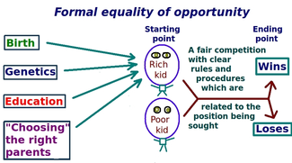
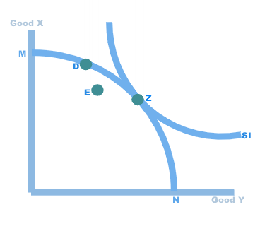
What is the problem with natural liberty?

    - Liberal equality = substantive equality of opportunity + the principle of efficiency

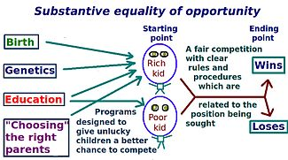

      - According to substantive equality of opportunity, two people with equal ability and willingness to expend effort will face the same life prospects. (So there should be an arrow from “Genetics” to both “Rich kid” and “Poor kid”). Thus Liberal Equality avoids the problem with Natural Liberty.

      - What programs might be required to implement substantive equality of opportunity? (See Other Mandatory Programs)

      - suppose Liberal Equality works perfectly. There’s still a problem. What is it?

    - Natural aristocracy – “an ideal feudal system might try to fulfil the difference principle” (TJ p. 64n12)

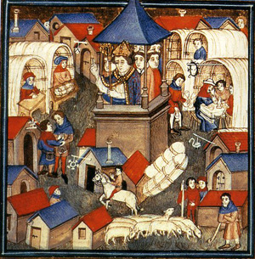

  - Why doesn’t Rawls offer these interpretations to the parties in the OP and argue against them there?

  - What does Rawls mean when he implies that we want an interpretation of the two principles “which treats everyone equally as a moral person”? (p. 65)

To see a fascinating on-going study of equality of opportunity in the US, click here.

